The Sixth Sunday of Easter
Liturgy of the Word
May 9, 2021 ~ 10:30 am
ONLINE WORSHIP BULLETIN

Christ is Risen!
Alleluia!
Acclamation
Alleluia! Christ is risen!
Christ is risen indeed! Alleluia!

Collect for Purity
Let us pray.
Almighty God, to you all hearts are open, all desires known, and from you no secrets are hid: Cleanse the thoughts of our hearts by the inspiration of your Holy Spirit, that we may perfectly love you, and worthily magnify your holy Name; through Christ our Lord. Amen.

Song of Praise Jesse Manibusan

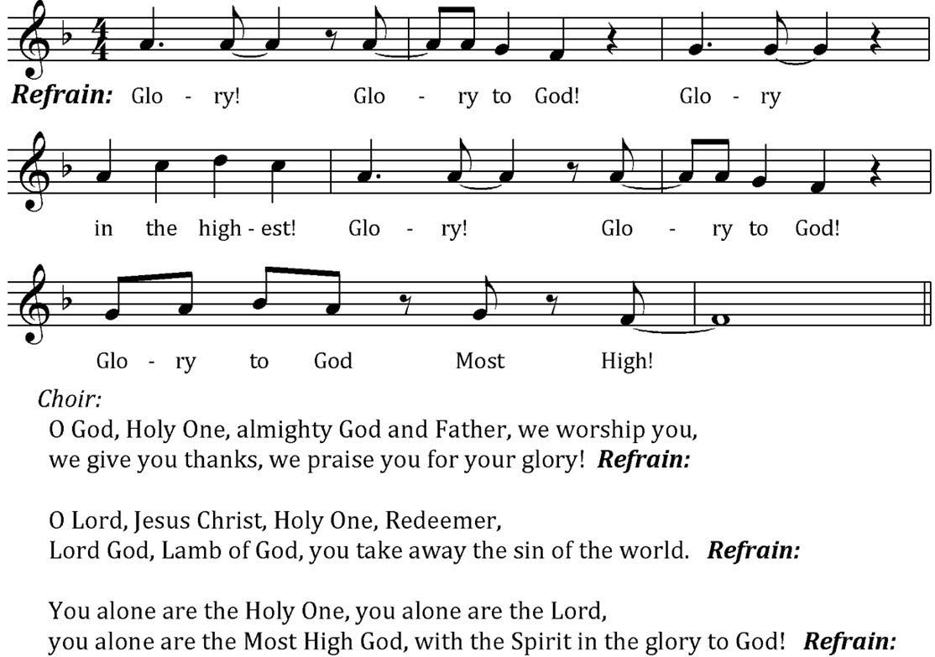

The Collect of the Day
May God be with you.
And also with you.
Let us pray.
O God, you have prepared for those who love you such good things as surpass our understanding: Pour into our hearts such love towards you, that we, loving you in all things and above all things, may obtain your promises, which exceed all that we can desire; through Jesus Christ our Lord, who lives and reigns with you and the Holy Spirit, one God, for ever and ever. Amen.

WORD

A Reading from the Acts of the Apostles Acts 10:44-48
While Peter was still speaking, the Holy Spirit fell upon all who heard the word. The circumcised believers who had come with Peter were astounded that the gift of the Holy Spirit had been poured out even on the Gentiles, for they heard them speaking in tongues and extolling God. Then Peter said, "Can anyone withhold the water for baptizing these people who have received the Holy Spirit just as we have?" So he ordered them to be baptized in the name of Jesus Christ. Then they invited him to stay for several days.

The Word of the Lord
Thanks be to God.

Psalm 98
Sing to the Lord a new song, *
for he has done marvelous things.
With his right hand and his holy arm *
has he won for himself the victory.
The Lord has made known his victory; *
his righteousness has he openly shown in the sight of the nations.
He remembers his mercy and faithfulness to the house of Israel, *
and all the ends of the earth have seen the victory of our God.
Shout with joy to the Lord, all you lands; *
lift up your voice, rejoice, and sing.
Sing to the Lord with the harp, *
with the harp and the voice of song.
With trumpets and the sound of the horn *
shout with joy before the King, the Lord.
Let the sea make a noise and all that is in it, *
the lands and those who dwell therein.
Let the rivers clap their hands, *
and let the hills ring out with joy before the Lord,
when he comes to judge the earth.
In righteousness shall he judge the world *
and the peoples with equity.

A Reading from the First Letter of John 1 John 5:1-6
Everyone who believes that Jesus is the Christ has been born of God, and everyone who loves the parent loves the child. By this we know that we love the children of God, when we love God and obey his commandments. For the love of God is this, that we obey his commandments. And his commandments are not burdensome, for whatever is born of God conquers the world. And this is the victory that conquers the world, our faith. Who is it that conquers the world but the one who believes that Jesus is the Son of God?

This is the one who came by water and blood, Jesus Christ, not with the water only but with the water and the blood. And the Spirit is the one that testifies, for the Spirit is the truth.

The Word of the Lord
Thanks be to God.

Gospel Alleluia: Celtic Hallelujah John Reager
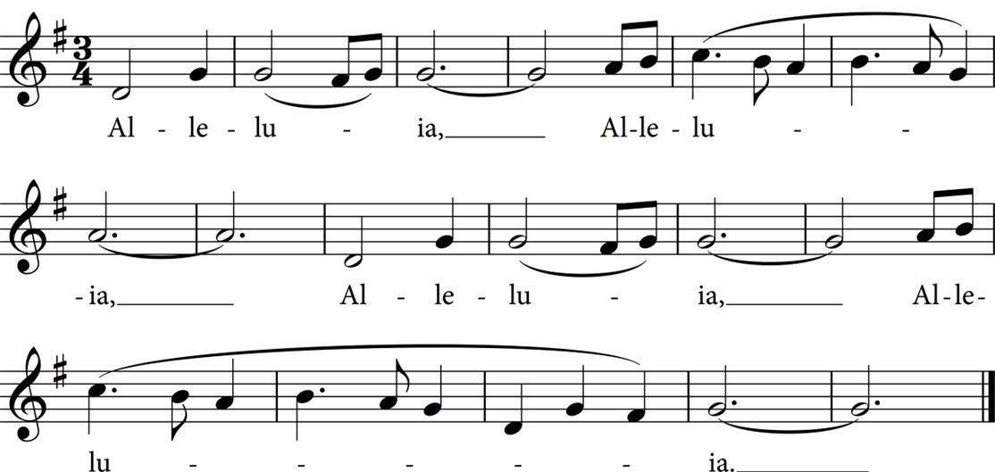

The Holy Gospel John 15:9-17
The Holy Gospel of our Savior Jesus Christ according to John.
Glory to you, Lord Christ.

Jesus said to his disciples, “As the Father has loved me, so I have loved you; abide in my love. If you keep my commandments, you will abide in my love, just as I have kept my Father’s commandments and abide in his love. I have said these things to you so that my joy may be in you, and that your joy may be complete.

“This is my commandment, that you love one another as I have loved you. No one has greater love than this, to lay down one’s life for one’s friends. You are my friends if you do what I command you. I do not call you servants any longer, because the servant does not know what the master is doing; but I have called you friends, because I have made known to you everything that I have heard from my Father. You did not choose me but I chose you. And I appointed you to go and bear fruit, fruit that will last, so that the Father will give you whatever you ask him in my name. I am giving you these commands so that you may love one another.”

The Gospel of Christ.
Praise to you, Lord Christ.

The Homily

The Nicene Creed
We believe in one God, the Father, the Almighty,
maker of heaven and earth, of all that is, seen and unseen.
We believe in one Lord, Jesus Christ, the only Son of God,
eternally begotten of the Father, God from God, Light from Light,
true God from true God, begotten, not made,
of one Being with the Father; through him all things were made.
For us and for our salvation he came down from heaven,
was incarnate of the Holy Spirit and the Virgin Mary
and became truly human.
For our sake he was crucified under Pontius Pilate;
he suffered death and was buried.
On the third day he rose again in accordance with the Scriptures;
he ascended into heaven and is seated at the right hand of the Father.
He will come again in glory to judge the living and the dead,
and his kingdom will have no end.
We believe in the Holy Spirit, the Lord, the giver of life,
who proceeds from the Father,
who with the Father and the Son is worshiped and glorified,
who has spoken through the prophets.
We believe in one holy catholic and apostolic Church.
We acknowledge one baptism for the forgiveness of sins.
We look for the resurrection of the dead,
and the life of the world to come. Amen.

The Prayers of the People
Awake, O Sleeper, rise from death,
And Christ will give you life!

Bring newness and change to your church, O God, that we might serve you with courage and grace. Awake, O Church, rise from death,
And Christ will give you life!

Bring newness and change to your world, O God, that all might know the goodness of your love. Awake, O World, rise from death,
And Christ will give you life!

Bring newness and change to our nation, O God, that each person might share and honor the other. Awake, O People, rise from death,
And Christ will give you life!

Bring newness and change for the suffering, O God, that they might know your saving help. Awake, O Sorrowful, rise from death,
And Christ will give you life!

Bring newness and change to even the departed, O God, that they might forever grow in your likeness. Awake, O Saints, rise from death,
And Christ will give you life!

Bring newness and change to our hearts, O God, that we might grow larger in faith and hope. Awake, O Soul, rise from death,
And Christ will give you life!

Awake, O Sleeper, rise from death, for Christ has burst forth from the tomb, making all things new. Rise and live, says the Lord. This day God has made for life and all joy! Amen, alleluia!

The Lord’s Prayer
As our Savior Christ has taught us, we now pray:
Our Father in heaven, hallowed be your Name,
your kingdom come, your will be done, on earth as in heaven.
Give us today our daily bread.
Forgive us our sins
as we forgive those who sin against us.
Save us from the time of trial,
and deliver us from evil.
For the kingdom, the power, and the glory are yours,
now and for ever. Amen.

The Peace
May the peace of Christ be always with you.
And also with you.

Welcome & Announcements

Thanksgivings of the Community
You are invited to come forward to offer public thanks for the movement of God’s Spirit in your own life: thanks for a birthday, an anniversary, a new job, and unexpected act of compassion, or another grace-filled change in your life. We close this time with the following prayer:

O God, our times are in your hands: Look with favor, we pray, on your servants as they mark this day. Grant that they may grow in wisdom and grace, and strengthen their trust in your goodness all the days of their lives; through Jesus Christ our Lord. Amen.

SENDING

The Blessing
May the God who formed all things in Love, draw you near to God’s own heart,
empower you by the power of the Spirit to live the Way of Love with fellow travelers,
and send you to participate in the resurrection and healing of God’s world.

And may the blessing of our Lord - loving, liberating, and live-giving - be with you and remain with you forever. Amen.

Processional: Alleluia, alleluia! Hearts and voices heaven-ward raise (v. 1-2) Lux eoi
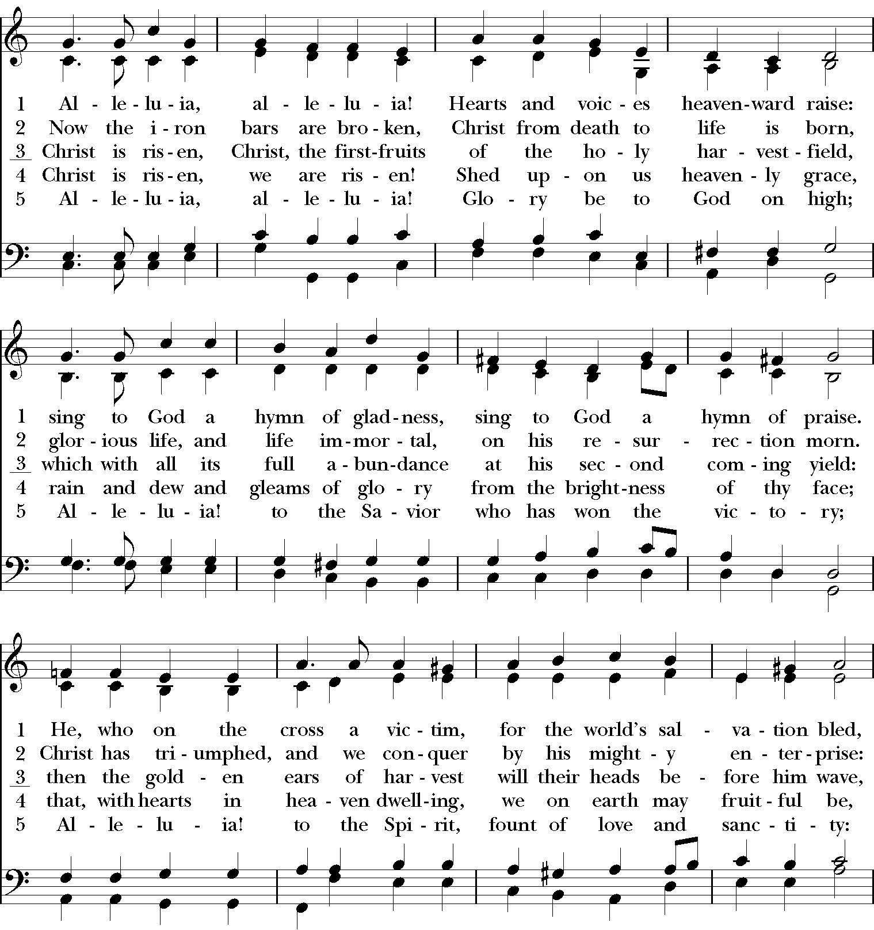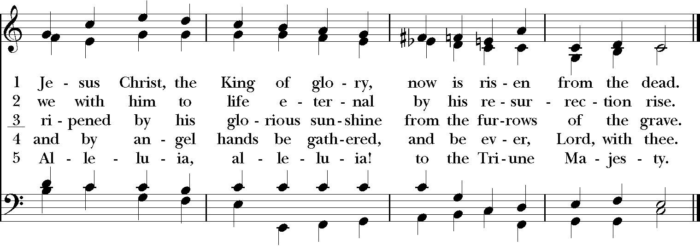
The Dismissal
Let us go forth in the name of christ, alleluia, alleluia!
Thanks be to God, alleluia, alleluia!

